The Magic of Mathematics in Art
Mathematics and art are two entirely different worlds: numbers and logic on one side, and creativity and feelings on the other. However, they have beautiful and fascinating modes of convergence. From ancient temples to modern digital paintings, mathematics is an invisible architect that shapes art and makes it more attractive. Let's take a look at that magical connection between the two fields.

1. Symmetry: The Balance of Beauty
Beauty is based on symmetry in nature and art. Half of the object reflects another half to create a balance and harmony. Artists used symmetry to make their creations look beautiful for centuries.
For example, the wings of a butterfly are perfectly symmetrical. Similarly, patterns of symmetry can be seen in mandalas, ancient embroidery, and stained glass windows. Even human faces are said to be the most beautiful when they are symmetrical!
Example

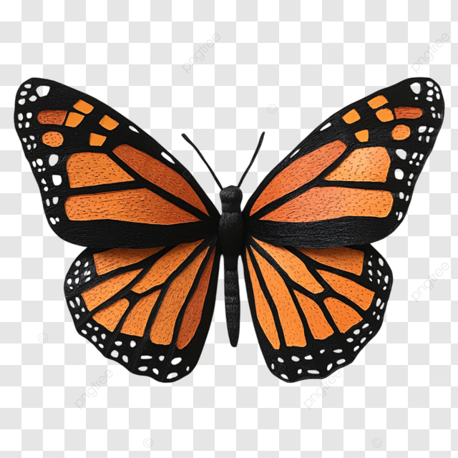
Imagine folding this butterfly along its centerline. The two sides perfectly match up. It is an outstanding example of natural symmetry.

2. The Golden Ratio: Nature's Secret Code
The Golden Ratio has a value of approximately 1.6181.6181.618. It has been termed "Nature's Perfect Number" because it occurs everywhere in sunflowers, galaxies, and even human DNA. Artists and architects often use the ratio to write pieces that somehow seem to be in perfect balance.

Formula
$φ= {(a+b)}/a=a/b= \frac{1+ \sqrt{5}}{2}$ where $a>b>0$.
The ancient Greeks used the Golden Ratio to design the Parthenon, a masterpiece of architecture. Similarly, Leonardo da Vinci used it to paint the Mona Lisa and Vitruvian Man, giving these works their timeless appeal.

Example
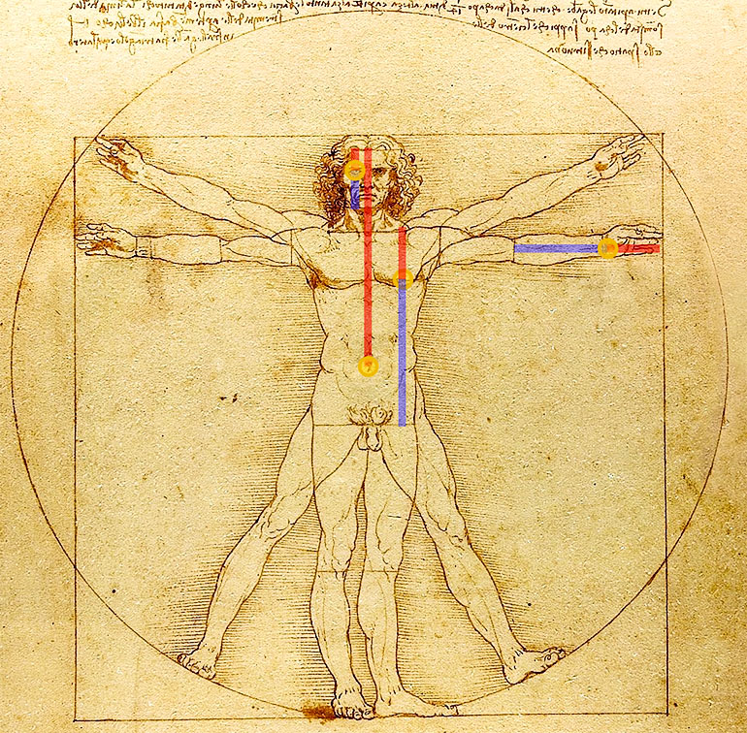
Notice how the proportions of the human body follow the Golden Ratio. It’s what makes Da Vinci’s work so captivating!

Source: https://www.futurity.org/golden-ratio-human-skull-2176162/

3. Tessellations: Repeating Patterns
Tessellations are a pattern of fitting shapes perfectly into each other, without gaps and overlaps. A mathematician and an artist, M.C. Escher, brought life to the tessellations by using some intricate, interlocking shapes with birds, fish, and reptiles.
Tessellations also demonstrate the major features in Islamic art because geometrical patterns help to create designs full of mesmerizing, infinite, and unified ideas.

Example
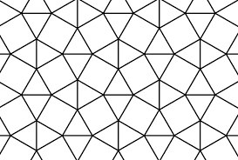
Source: https://www.cantorsparadise.org/tessellations-ft-harrys-tiles-4c41315649c8/

4. Möbius Strip: One Side, Endless Wonder
A Möbius strip is a mathematical object with just one side and one edge. One can imagine giving a half twist to a strip of paper, joining its ends together. What is obtained will be quite an interesting shape that challenges our familiar concept of surfaces!
Möbius strips are often used by artists and sculptors to study concepts of infinity and continuity. M.C. Escher, for instance, wrote many pieces based on this shape, whereas contemporary sculptors used it as a base to create public artworks.

Did You Know?
You can draw a line down the middle of a Möbius strip and you'll end up at your starting point, never lifting your pencil–a demonstration of its only having one side!

Example
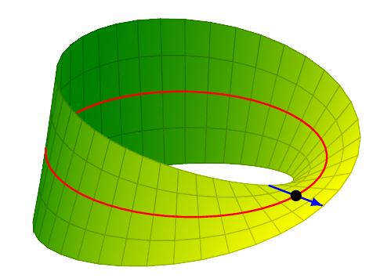
Source: StackExchange

5. Fractals: Infinite Complexity
A fractal is a shape that looks the same at every scale, no matter how much you zoom in or out. The art is then generated using mathematical formulas, and some of these can be found in nature, for example, through snowflakes or the clouds and trees.
Artists and designers utilized fractals to create stunning digital designs. These infinite patterns reflect the complexity and magnificence of the world around us.

Example

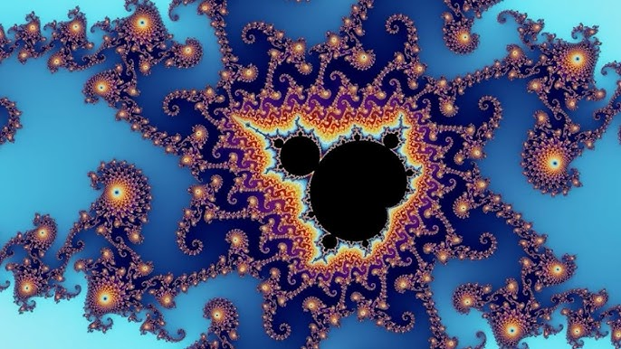
Source: Youtube

6. Perspective: Adding Depth to Art
Before the Renaissance, paintings were two-dimensional. Then came the discovery of linear perspective, a technique based on geometry. Artists began using vanishing points and converging lines to create the illusion of depth, making their paintings more lifelike.

Example
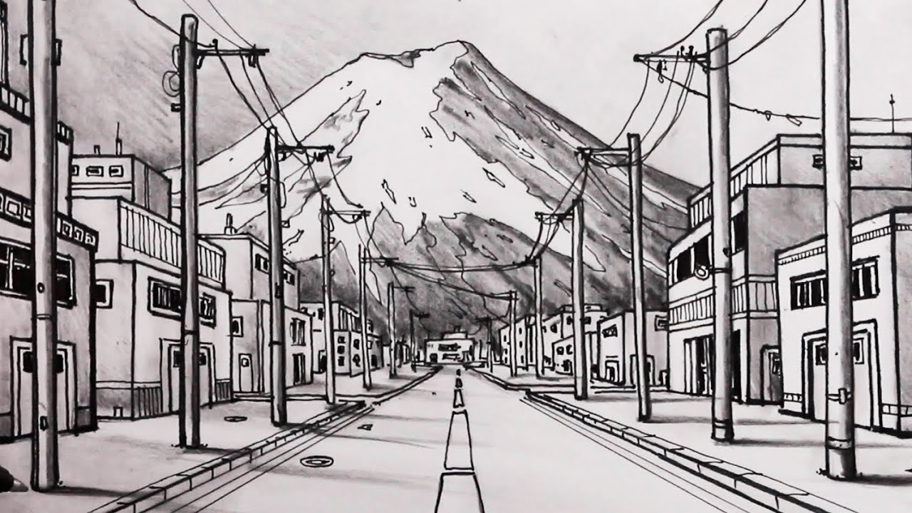
Imagine standing on a road and looking into the distance. The road seems to narrow as it stretches away. That's perspective in action!

Source: Youtube

7. Geometry in Sculpture and Architecture
From the Great Pyramids in Egypt to the glass pyramid at the Louvre, geometry shapes our world. The principles of geometry are used by artists and architects in designing structures that are useful and aesthetically pleasing.
Circles, squares, or triangles ensure harmony, balance, and strength in designs. Such is the case of the Taj Mahal- its very perfect symmetry and geometric layout have made this architectural wonder one of the most admired structures the world has ever known.

Conclusion
Mathematics is not about solving equations or using formulas only; it helps us see, understand, and create beauty by itself. Think of the beauty of symmetry, like in butterflies, fractals in digital artwork, or that Möbius strip with a surface that runs on forever-that's math mixed with art, inextricable.
The next time you view a painting, sculpture, or building, remember the math that went into the making of that masterpiece. Who knows? Perhaps mathematics will inspire you to create something amazing, too!

